Spring and Spring Boot

Spring is a java-based framework that simplifies developing enterprise applications in java. It makes it easy to develop web applications by providing features like,
Spring IoC container
IoC container is key component in Spring framework which is responsible for configuring beans and managing bean lifecycle. It achieves this by using dependency injection (DI) to decouple the creation and management of objects from their usage.
Spring has many different modules like

Spring AOP
Spring provides AOP feature enabling us to separate cross cutting concerns(logging, Security, Transaction management, Caching ..etc)

Spring ORM
Spring ORM module provides integration with ORM frameworks such as Hibernate, JPA, JDO and others.
Key Features:
- Integration with Hibernate and JPA
- Declarative Transaction Management by using @Transactional
- Exception Translation
  - Generally, when integrated with ORM framework like hibernate. If any persistence related code throws exception it would be a hibernate exception.
  - Spring wraps these hibernate exceptions into Spring data exceptions
- Spring data JPA
  - Spring Data JPA takes ORM integration a step further by reducing the amount of boilerplate code needed to access the database. It provides a set of repository interfaces, which you can extend to create your own repository interfaces.

Spring Web MVC
Spring Web MVC is a module of the spring framework that provides a comprehensive approach to build web applications. It follows MVC design pattern, which separates the application into 3 interconnected components:
Model: represents application data and business logic.
View: Represents the presentation layer, which is responsible for rendering the UI.
Controller: Handles User requests, process them and returns appropriate view.
Spring Boot provides autoconfiguration feature
Spring Boot auto-configuration is a powerful feature that streamlines application setup by automatically configuring your Spring application based on the JAR dependencies you include.
Here's a comprehensive explanation of Spring Boot auto-configuration:
How it Works:
- Spring Boot scans your classpath for relevant JAR dependencies.
- Based on the dependencies found, it activates specific auto-configuration classes.
- These classes are responsible for creating Spring beans (components) needed for various functionalities.
- Auto-configuration uses conditional annotations to ensure beans are only created if necessary conditions are met (e.g., a specific library is present).
Benefits:
- Reduced Boilerplate: Saves you time and effort by eliminating the need for manual configuration of common beans.
- Simplified Development: Focus on application logic instead of low-level configuration details.
- Improved Maintainability: Easier to understand and manage application configuration.
- Convention over Configuration: Spring Boot follows conventions for configuration, making your application predictable and consistent.
Key Concepts:
- @EnableAutoConfiguration: Enables auto-configuration for your application (usually included in @SpringBootApplication).
- Conditional Annotations: @ConditionalOnClass, @ConditionalOnProperty, etc., control when auto-configuration is applied.
- Auto-Configuration Classes: These classes define the logic for creating beans based on dependencies.
- Custom Auto-Configuration: You can create your own auto-configuration classes for specific needs.
Customization:
- Override Auto-Configuration: Define your own beans to replace those created by auto-configuration.
- Disable Auto-Configuration: Use annotations like @EnableAutoConfiguration(exclude={...}).
Learning More:
- Spring Boot documentation on Auto-Configuration: [Spring Boot Auto-configuration ON spring.io]
- Creating a Custom Auto-Configuration: [Baeldung Create a Custom Auto-Configuration with Spring Boot] (consider searching for this topic without the link)

Springboot provides embedded servers
Spring Boot applications can leverage embedded servers. This means the web server (like Tomcat, Jetty, or Undertow) is packaged within the application itself, eliminating the need for a separate server installation.
Here's a closer look at embedded servers in Spring Boot:
- Benefits:
  - Simplified deployment: No need to install or configure a separate web server on the target environment.
  - Lightweight applications: Embedded servers are generally smaller than full-fledged web servers.
  - Faster startup times: Applications can start quicker since the server is already bundled.
- Supported Servers:
  - Spring Boot offers built-in support for popular embedded servers like Tomcat (default), Jetty, and Undertow.
  - You can choose the server based on your application's requirements and preferences.

Springboot provides Starter dependencies,
Spring Boot starters are pre-configured dependency bundles that simplify dependency management in your Spring Boot applications. Instead of manually adding individual libraries, you can include a starter dependency to bring in all the necessary libraries for a specific functionality.
Examples:
- spring-boot-starter-web: Provides libraries for building web applications using Spring MVC.
- spring-boot-starter-data-jpa: Includes libraries for database access with JPA.
- spring-boot-starter-test: Bundles libraries for unit and integration testing.
Spring vs Spring Boot

Spring Boot Actuator
Spring Boot Actuator is a sub-project of Spring Boot that provides a set of features for monitoring and managing your Spring Boot applications. It offers several benefits:
• Simplified monitoring: Accesses various aspects of your application's health and performance through HTTP endpoints or JMX. This eliminates the need to write custom code for monitoring purposes.
• Improved manageability: Provides endpoints to interact with your application, such as shutting it down or restarting it.
• Production-ready features: Includes features like health checks, metrics gathering, and environment information exposure, all crucial for production environments.

Connect Multiple databases in Spring Boot Application:
We need to create two configuration classes for two different entities. In the configuration classes we need to give @Bean methods for data source, EntityManagerFactory and Transaction manager.
@Primary
In Spring Boot, the @Primary annotation is a helpful tool for managing situations where you have multiple beans of the same type. It essentially acts as a tie-breaker during autowiring, telling Spring which bean to prioritize.
Here's a breakdown of how @Primary works:
- Scenario: Imagine you have two classes, JdbcMovieRepository and HibernateMovieRepository, both implementing the MovieRepository interface. Spring can get confused if you try to autowire a MovieRepository dependency because there are two options.
- @Primary to the rescue: By annotating one of the repositories (say HibernateMovieRepository) with @Primary, you explicitly tell Spring that this is the preferred choice if both are available.
- Selection process: During autowiring, Spring will look for beans that can be assigned to the dependency type. If it finds multiple beans of the same type, it will check if any of them are marked as @Primary. If exactly one bean is @Primary, that's the one that gets autowired.

@RestController
In Spring Boot, the @RestController annotation is a convenient way to build RESTful web services. It combines the functionalities of two other annotations:
- @Controller: This annotation marks a class as a Spring MVC controller, meaning it can handle incoming HTTP requests.
- @ResponseBody: This annotation tells Spring to treat the return value of a request handling method as the response body itself. Spring will automatically serialize the object (often to JSON or XML) and include it in the HTTP response.
By using @RestController, you achieve both functionalities in a single annotation, simplifying your code. Here's a closer look:
- Creating RESTful APIs: @RestController is specifically designed for building RESTful APIs. These APIs adhere to REST principles for resource-oriented communication using HTTP methods like GET, POST, PUT, and DELETE.
- Automatic response serialization: As mentioned earlier, Spring takes care of converting the object returned by your controller method into a suitable format (like JSON) for the client application to understand.
- Simplified code: Compared to using @Controller and @ResponseBody separately on every method, @RestController keeps your code cleaner and more concise.

Spring-boot-starter-parent:
Adding spring-boot-starter-dependency provides dependency management.
It manages the versions of all the libraries the project depends on. This helps to avoid conflicts and provides compatibility between different components.

Prometheus
Prometheus is an open-source toolkit specifically designed for monitoring systems and alerting. It excels at collecting and storing metrics data in a time-series format, allowing you to analyze trends and diagnose issues over time. Here's a breakdown of its key functionalities:
Metrics Collection and Storage:
- Time-series data: Prometheus focuses on recording metrics as time-series data. This means each data point is associated with a timestamp, enabling you to track how metrics change over time. It's particularly useful for monitoring system performance and resource utilization.
- Pull model: Prometheus utilizes a pull model for data collection. Instead of relying on monitored systems to push data, Prometheus actively scrapes metrics from predefined endpoints exposed by applications and infrastructure.
- Flexibility: Prometheus can collect various metrics, including CPU usage, memory consumption, request latency, and custom application-specific metrics.
Alerting and Visualization:
- PromQL: Prometheus provides a powerful query language called PromQL. This language allows you to write complex queries to extract specific insights from the collected metrics data. You can use PromQL to filter, aggregate, and analyze time-series data to identify anomalies and potential problems.
- Alerting: Based on the results of PromQL queries, Prometheus can trigger alerts when certain conditions are met. This enables proactive monitoring and helps you identify issues before they become critical.
- Visualization: Prometheus integrates well with various visualization tools like Grafana. These tools allow you to create dashboards and graphs to visualize your metrics data efficiently. By seeing trends and patterns over time, you can gain valuable insights into system health and performance.

Spring Boot caching
Spring provides Cache Abstraction API that allow us to use different cache providers to cache objects.
When the caching is enabled, the application will start looking in cache first for any object request, If the object doesn’t exist in cache, then it will look in the database.
Cache abstraction works on two things,

Cache Declaration
Identifies the methods that need to be cached

Cache Configuration
The backed cache where data is stored and read from.

Dependencies
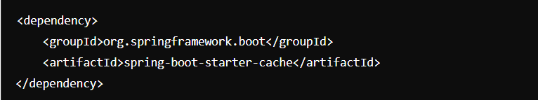

Enable Caching
Caching is enabled in our application by making use of the annotation @EnableCaching on main class.

Configure cache
Spring Boot provides several caching providers, such as Ehcache, Hazelcast, and Redis. You can configure your preferred caching provider in the application.properties or application.yml file.

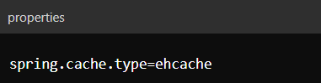
If we don’t configure any cache, ‘then Spring will auto configure ConcurrentMapCacheManager which uses a ConcurrentHashMap for caching.

Annotations
@Cacheable is a method level annotation, indicates that the result of a method should be cached and for subsequent requests with the same parameters should return the cached response.
We can provide the cache name where we want the data to be cached by using the parameters value or cacheNames.
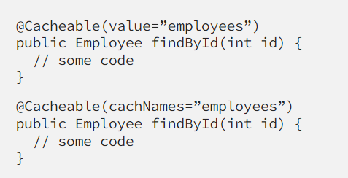

@CachePut is a method level annotation which is used to update the cache. Unlike @Cacheable, @CachePut does not check the cache before invoking the method, It will execute the method and the result will be updated in cache. This is useful when we want to ensure that cache is updated with the latest data after performing an operation like saving or updating an entity.

@CacheEvict is a method level annotation which is used if we want to delete any cached object. This is generally used with Delete/Update methods.
@Caching is a method level annotation The @Caching annotation in Spring allows you to group multiple caching annotations (@Cacheable, @CachePut, and @CacheEvict) on a single method. This is useful when you need to perform multiple caching operations in a single method execution.
The @CacheConfig annotation in Spring is used to share some common cache-related settings at the class level. This helps to avoid redundancy when multiple methods within the same class use the same cache settings. You can define the default cache names and other common configurations at the class level, and individual methods can override these defaults if needed.

Redis (Remote Dictionary Server)
Redis is an open source, in-memory, NoSQL key-value store that is used primarily as an application cache.

Implementation:
Add dependencies
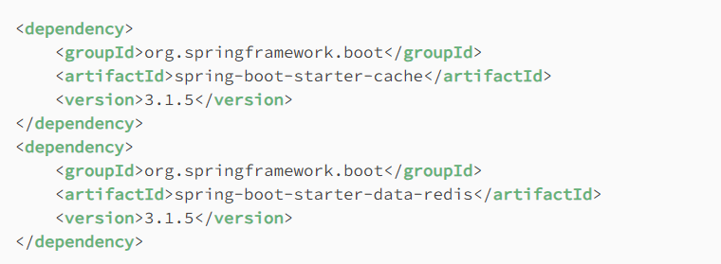
Configuration
By adding the above dependencies and the @EnableCaching annotation, Spring Boot will auto-configure a RedisCacheManager with default cache configuration. However, we can modify this configuration prior to cache manager initialization in a couple of useful ways.

1. By creating a RedisCacheConfigurationBean.
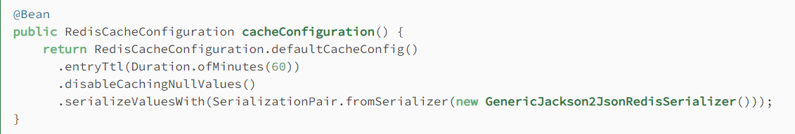
2. In order to have full control over the caching setup, let’s register our own RedisCacheManagerBuilderCustomizer bean

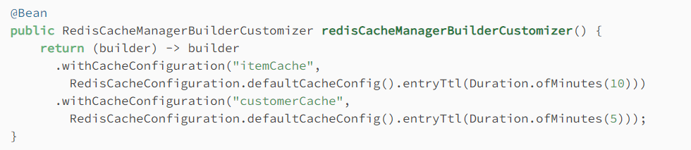

Spring Security:
Learnt from watching Java brains here

What is Spring security really all about ??
By using Spring Security, we provide application-level security for our programs.
We don’t need to care about OS level security, Server level security. But providing application-level security is our responsibility to protect our application.
Spring security can handle common security vulnerabilities like,
- Session fixation
- Click jacking
- Cross Site Request Forgery

Five Spring Security concepts
Authentication : It is the process of identifying the user. We do it in many ways like
- Knowledge-based (username & password)
- Possession-based (otp, verification codes)
- Multi-factor authentication (Knowledge + possession)
Authorization : Process of validating whether the user has access to perform an action in the application is called Authorization.
Principal : Principal is the digital user who has been identified by authentication.
In simple terms, Principal is a current logged in user.
Role : Group of authorities assigned together.

Adding Spring security to the application
We need to add spring-boot-starter-security to our application.
- By just adding the above dependency to our application, Spring creates a Login form and interrupts all the APIs of the application for authentication.
- Interrupting all the APIs is done by filters (concept of servlet) as Spring framework was built upon servlet.
- Handles login error
- Creates a user and sets a default password

Authentication
Authentication in Spring can be done using WebSecurityConfigurerAdapter. This class has a method configure(AuthenticationManager).
Using the AuthenticationManager object we can implement authentication in our application.

Authorization
Authorization in Spring can be implemented by getting hold of HttpSecurity object. This can be done by extending WebSecurityConfigurerAdapter class.
WebSecurityConfigurerAdapter class also has configure method that takes HttpSecurity Object as parameter. By overriding this method, we can get hold of HttpSecurity object and implement Authorization based on roles of the user.

In Spring Security 5.7.2M WebSecurityConfigurerAdapter class has been removed.

How Spring Security authentication works ?
Generally all the requests to servers in applications are interrupted by filters.
Filters is a concept of Servlet which will be intercepting the requests for doing some operations and validations on requests.
There could be multiple filters that interrupts the request. One of these filters will be authenticating the users.

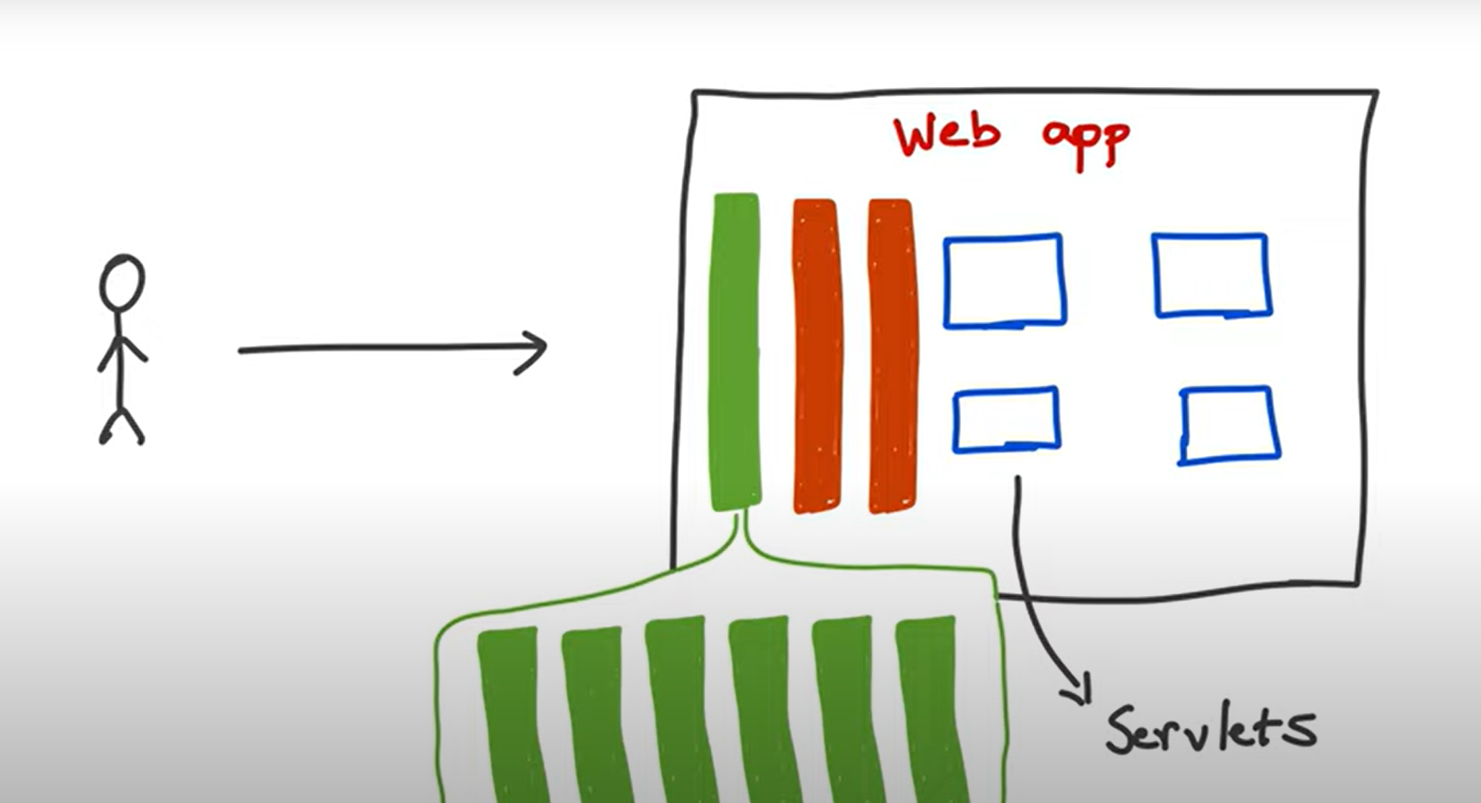

The filter that is providing authentication functionality will be making use of AuthenticationManager object.
Authentication Manager will be delegating the request to right AuthenticationProvider and validating the user.
We need to implement the AuthenticationProvider interface in our application.
AuthenticateManager has one method authenticate(Authentication) that takes Authentication object as param and returns Authentication.
AuthenticationProvider has authenticate() used for authentication functionality. Supports() is called to check whether the provider supports the type of authentication.

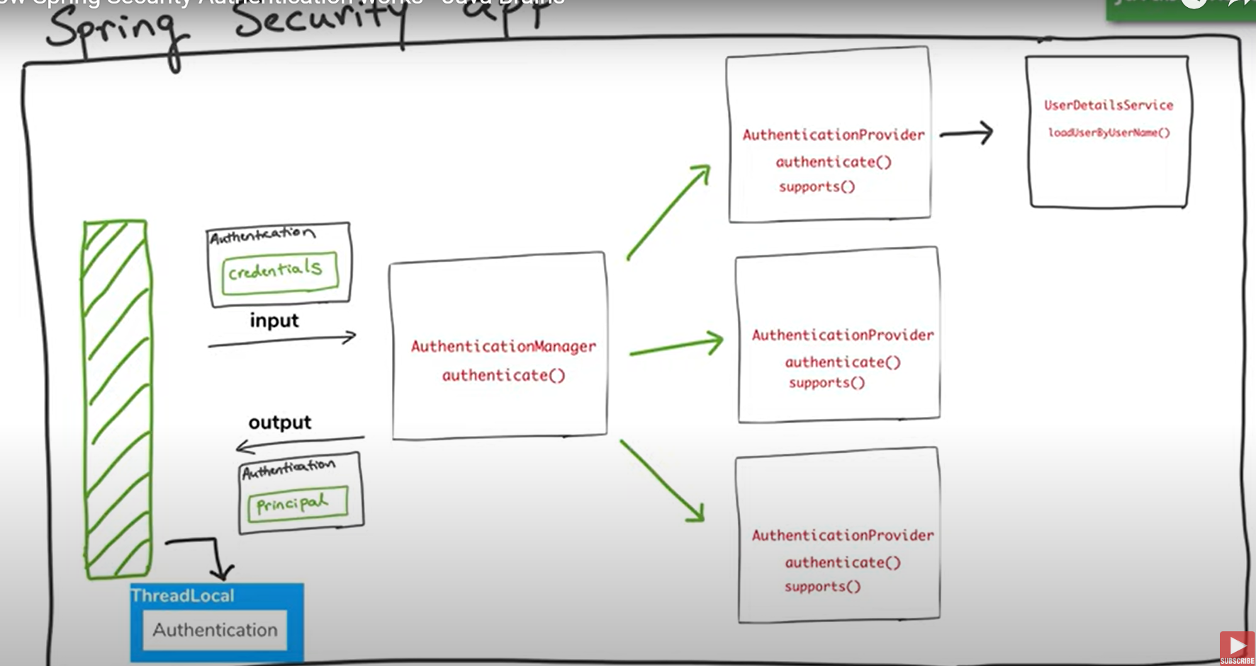
JWT:
Jason web tokens used for authentication and authorization of a user.
Generally, when we visit a web application, we will have to login to the application first.
After authentication user will be assigned with a JWT so that user will not be authenticated for every subsequent request.
We can say that JWT is used for both authentication and authorization.
It consists of 3 parts ,
Header. Payload. Signature.
Header contains the metadata like , type of the token and the algorithm used for signing the token.
{
"alg": "HS256",
"typ": "JWT"
}

Payload contains the claims of the user and user identification.
{
"sub": "1234567890", // Subject (user ID)
"name": "John Doe", // User's name
"admin": true, // Custom claim indicating admin privileges
"roles": ["user", "admin"], // Roles for authorization
"iat": 1516239022, // Issued at
"exp": 1516242622 // Expiration time
}
Signature is created by the encoded header and payload are concatenated with a period (.) and signed using a cryptographic hash function with a secret key or a private key (in the case of asymmetric algorithms).

Header, payload and Signature are Base64 encoded and looks like this
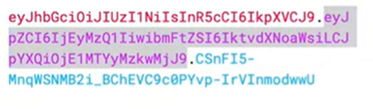
As secret key need to be stored and maintained secretly it is recommended to store in Kubernetes secret.

jwt-spring-boot-3

